Assignment – 8

1. Create a validation rule for the Accounts object where the type is ‘Customer-direct’ and industry is ‘ ’ with an error message ‘Please provide industry type’.
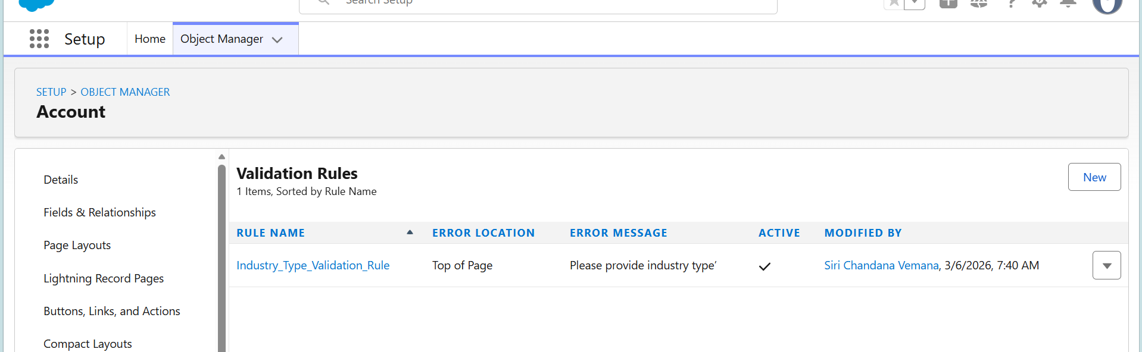
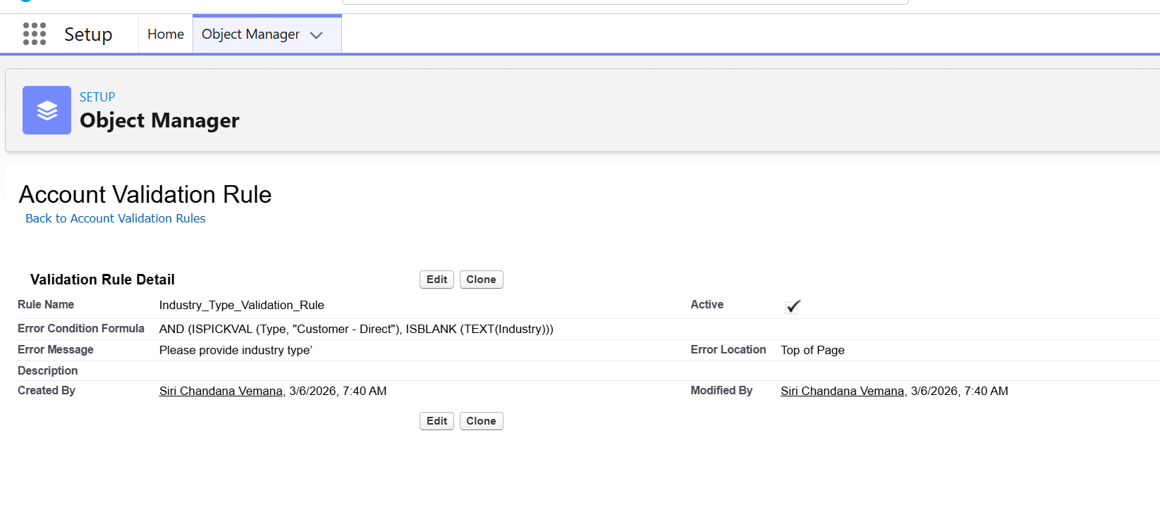
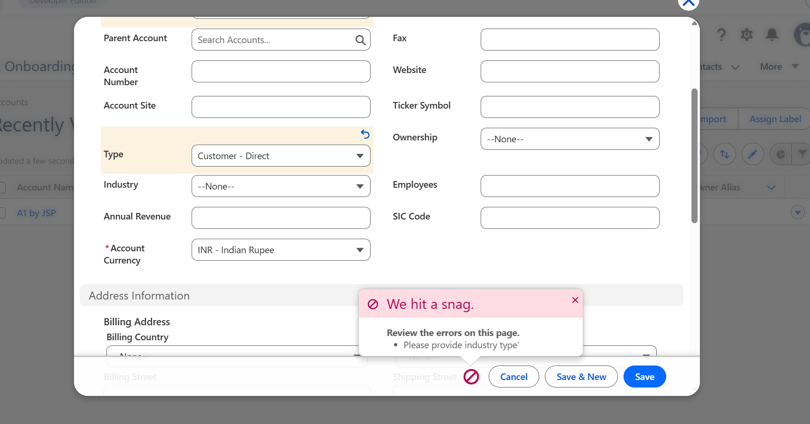

2. Create workflow rules for the Opportunity object where the opportunity amount is greater than US$1000. Add workflow actions for updating the Opportunity field with the formula ‘VIP Customer’+ Name if the amount of the opportunity is greater than US$1000.
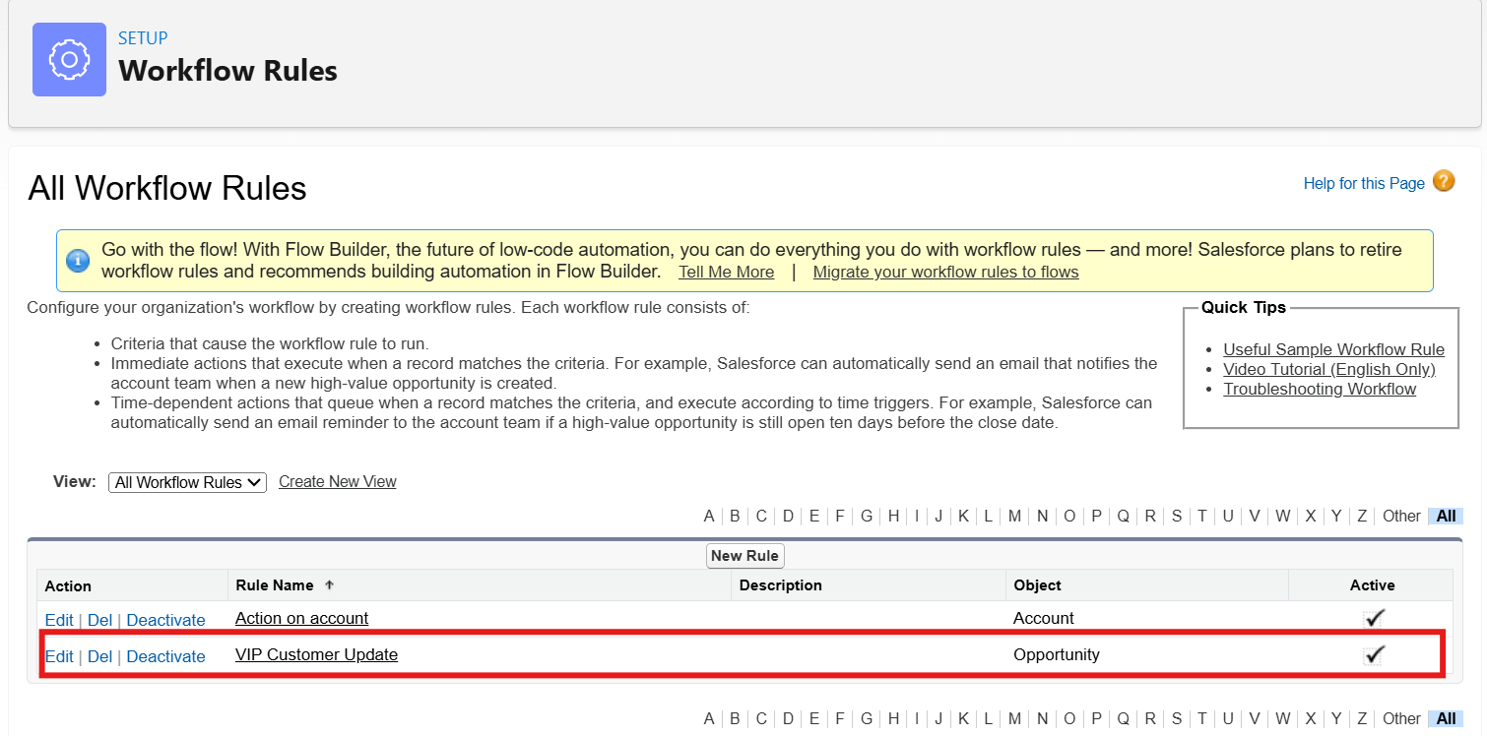
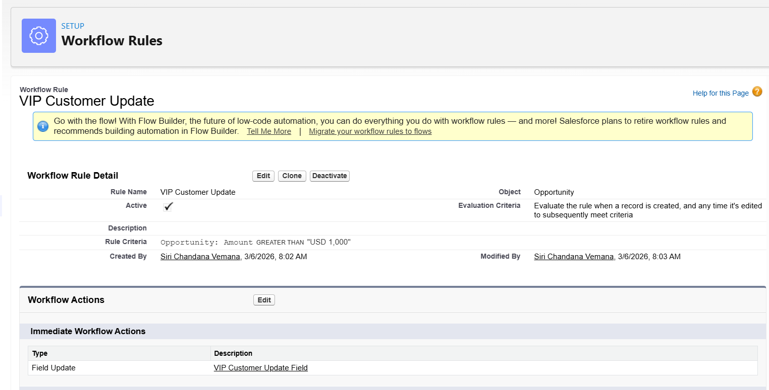

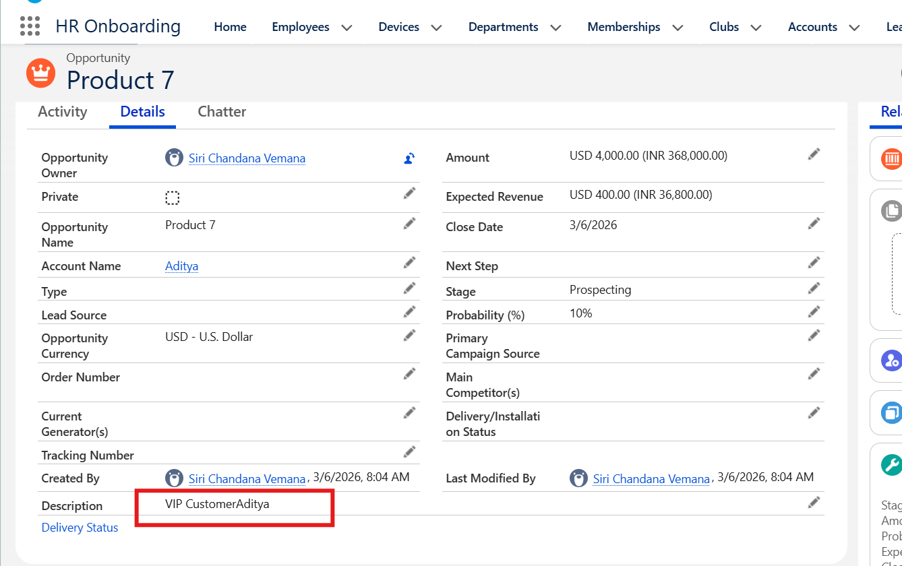

3. Create a flow for sending an email with Screen Flow as ‘Auto launched Flow’ and add the flow to the Leads object.
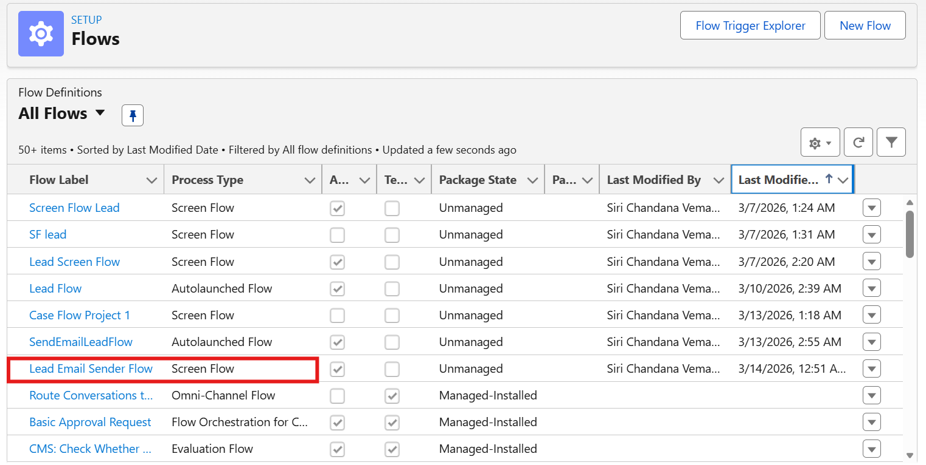
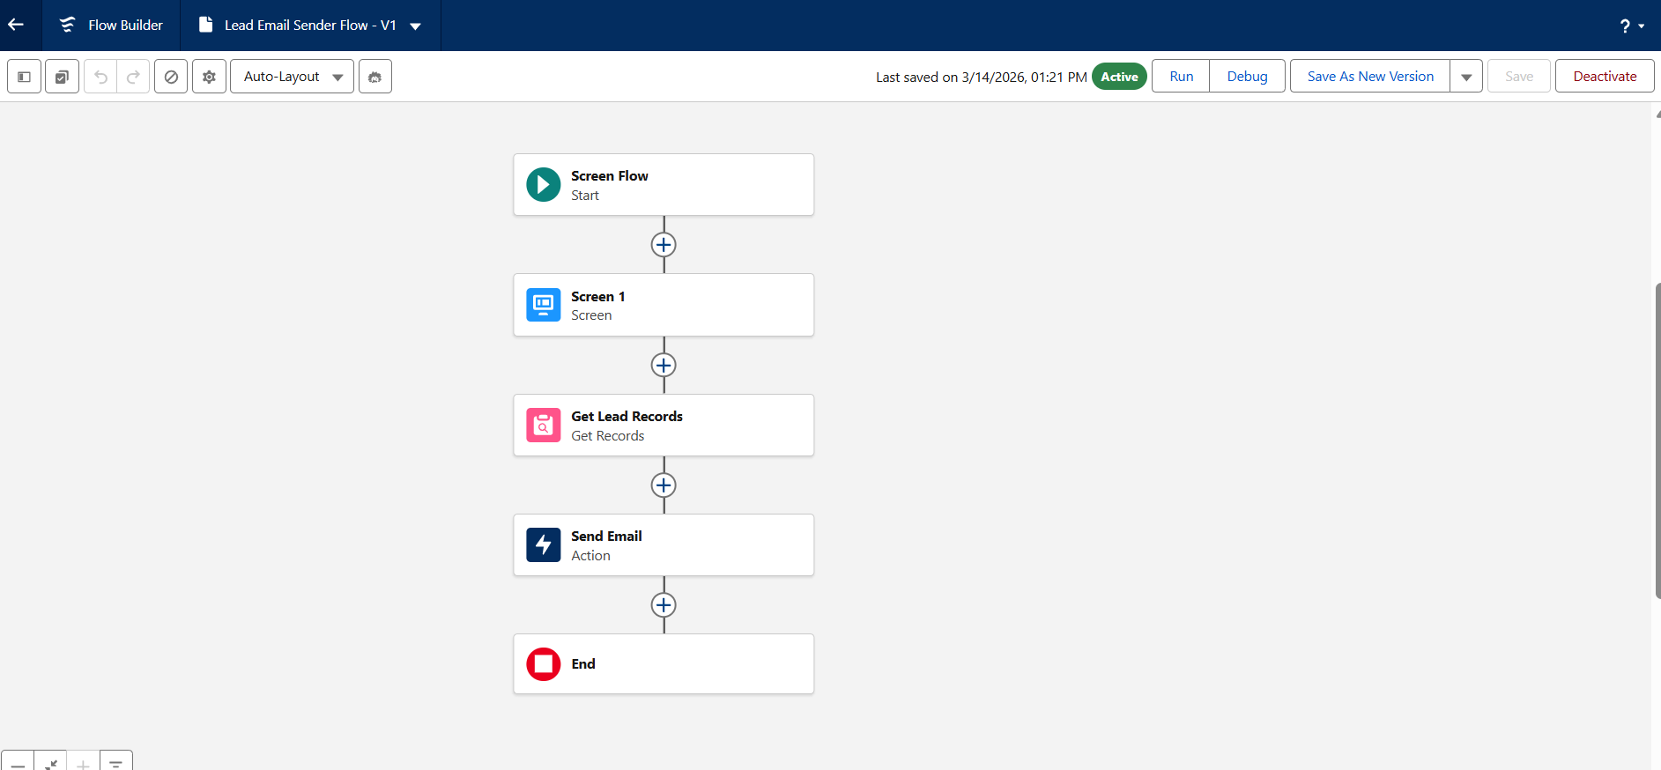
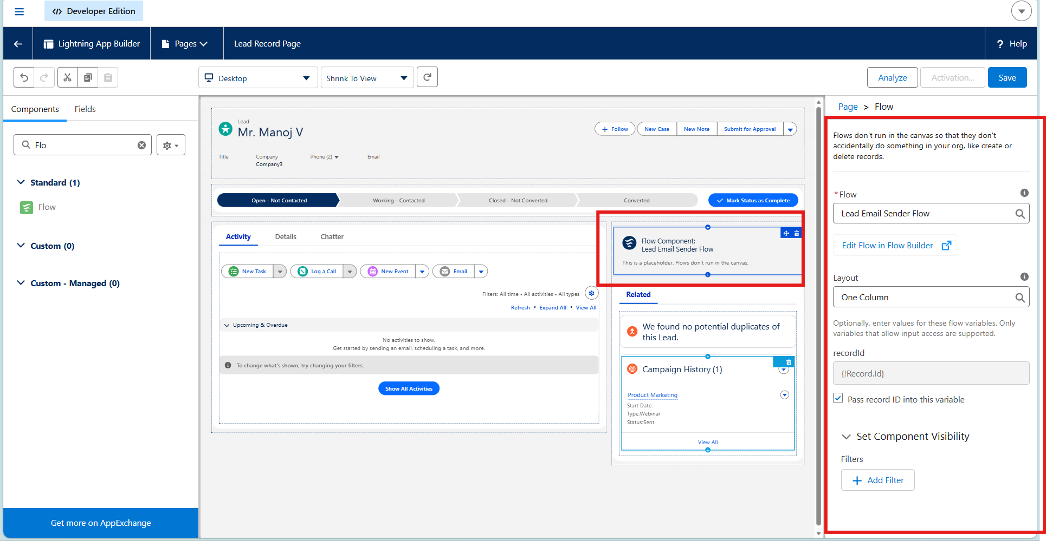

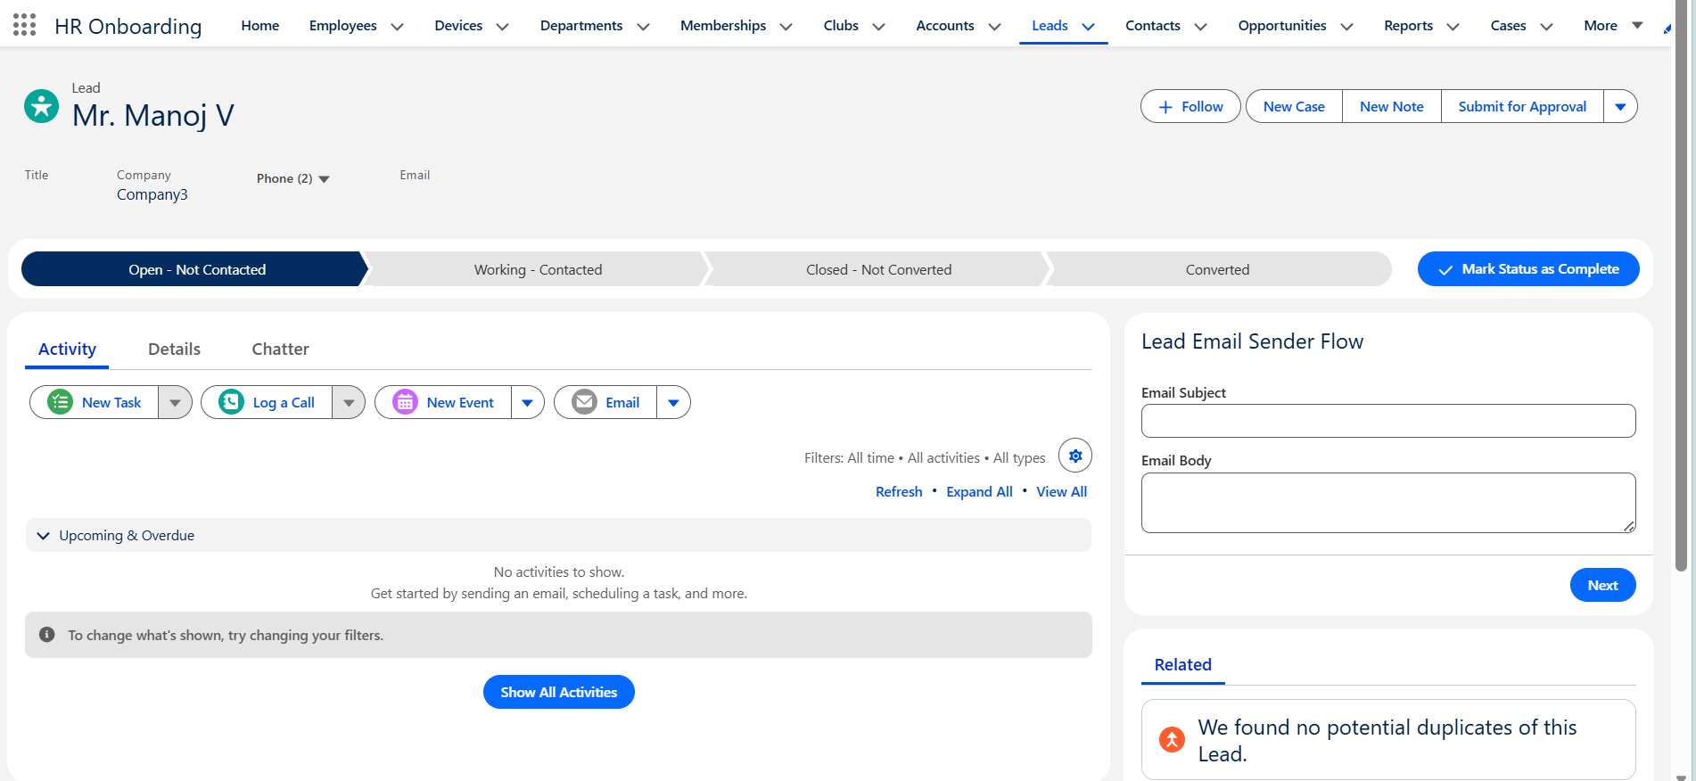

4. Create a process builder for the Opportunity object with an amount field. When the opportunity amount is US$5000, update the record as ‘VIP Customer’.
